## A PROVEN TRACK RECORD https://bgrdc.com/wp-content/uploads/2020/05/health1.jpg

**Client Testimonials**

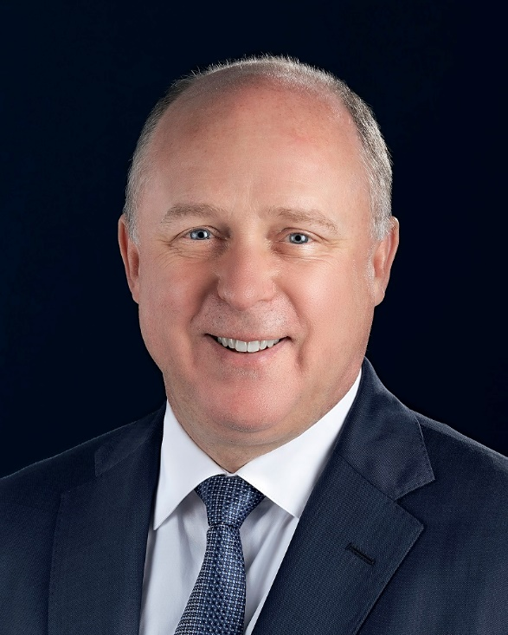

“Aside getting a cover feature on Pleasures magazine, our latest Gulfstream G700 was published in over 200 premium media platforms that were strategic to our target markets. Additionally, the campaign Ad was aired on CNN, which really showcased their abilities along with their relationships to create a dynamic branding/marketing campaign. As you can see their approach is very holistic, which we found is key to a successful campaign. Again, we couldn't be happier with our experience.”—**SCOTT NEAL – Senior Vice President Worldwide Sales, Gulfstream Aerospace Corporation**

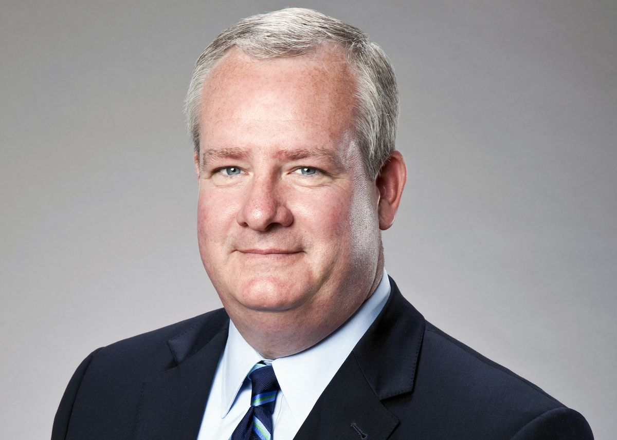

“Along with boxing legend Gerry Cooney, I have had the absolute pleasure of working with Dotmount Communications on the promotion of our book. Mr. McCormick’s indefatigable efforts resulted in far more PR opportunities than we could ever have imagined. Mr. McCormick was extremely responsive to emails (even on weekends), connected us with some of the top names in the industry, etc. – and did so with class, enthusiasm, and vigor. It has been an honor working with Mr. McCormick, and we encourage anyone in need of expert PR guidance to contact his agency immediately.” **– John Grady**



“Dotmount Communications has helped position us as a global leader in building with shipping containers. In the ﬁrst 60 days of working with them, they secured placements for us with ABC News, Associated Press, USA Today, and a Yahoo article with 2,200 comments, we saw a 2,000% increase in website traﬃc, 5+ business inquiries per day, $300,000,000 in potential projects brought to us, additional investment capital, and we leveraged the exposure to attract the attention and talent of the likes of Eric Lloyd Wright, grandson of Frank Lloyd Wright, widely thought to be the most inﬂuential architect of the 20th century.”—**LESLIE HORN, Three Squared, Inc.**

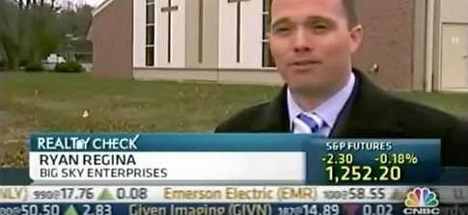

*“We were published in multiple magazines and other publications that were strategic to our target markets.  Additionally, we were interviewed on CNBC, which really showcased their abilities along with their relationships to create a dynamic branding/marketing campaign.  We received professional public speaking training which has really helped us with providing a clear, concise and powerful message to our target audience.  They designed our websites and provided the content necessary to have consistent brand messaging.  As you can see their approach is very holistic, which we found is key to a successful campaign.  Again, we couldn’t be happier with our experience.”* **– MIKE REGINA,** Partner Big Sky Big Sky Enterprises

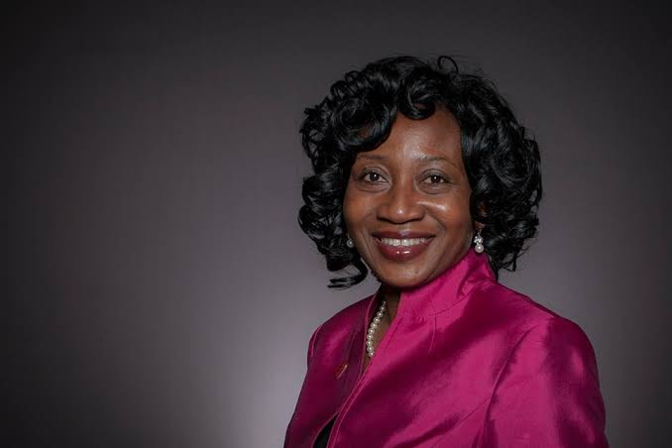

“*Thanks to the efforts of The Dotmount Communications team, the company got the necessary media exposure to set them up for future success as well as facilitate partnerships within their industry. The team was straightforward with their communication and delivered exactly what they promised.*” **DR REMI DUYILE, Former Vice President Bank of America**

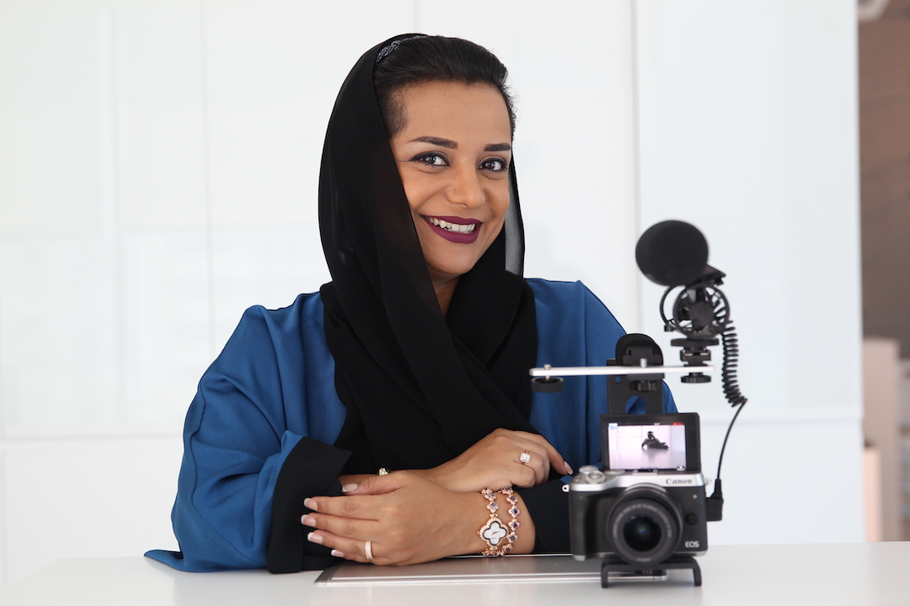

““I had the pleasure of working with Dotmount Communications. The connections they made and doors they opened were, and continue to be, highly valuable to me and my career. I am looking forward to working with them again very soon. They truly are the best in the world–and that’s not easy!!” **- NAYLA AL KHAJA - First female ﬁlms producer from the UAE**

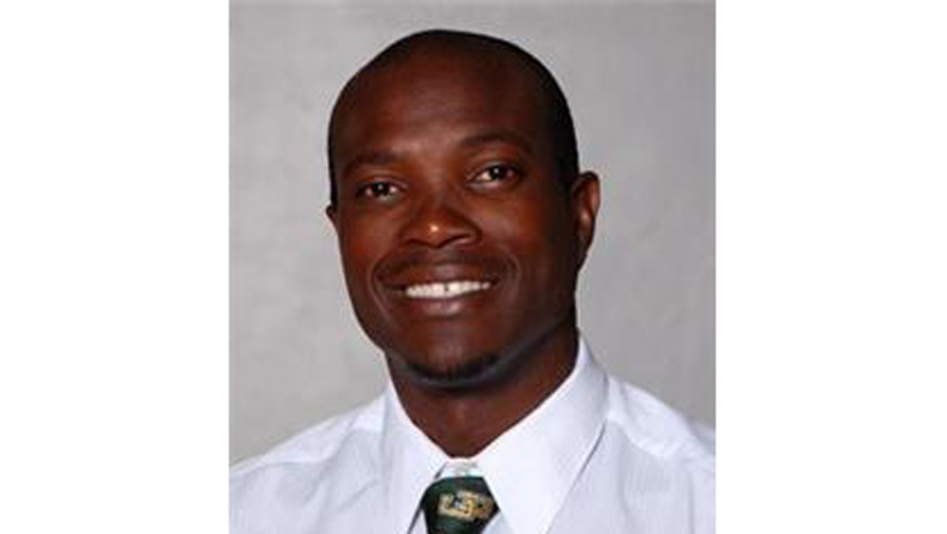

“This morning I stood at the precipice of either spending life in prison or finally going home to my family. Dotmount Communications is a big reason why I’m going home to my family.” **Nick Hillary (Wrongly Accused of Murder)**



“Powerful, connected, brilliant, dedicated, generous, and always gentlemanly. I can’t say enough about the effective PR and marketing genius of Dotmount Communications. Bravo and thank you for everything!” –**Judith Regan / Publishing Legend**



“I have used Dotmount Communications for various projects over the years and I can say they over deliver, every single time! They know the nuances of media and understand how to get the job done without all the nonsense you get from many other firms. I highly recommend this firm if you need to crank your message out. they are very attentive and easy to work with!” **– Attorney David Schwartz Attorney**

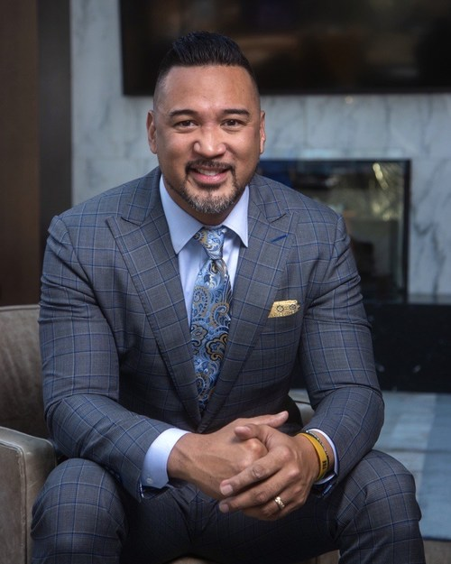

“I’ve been working with Dotmount Communications since 2018 and NO ONE compares in the industry. They are my FIRST and ONLY choice. High value, high relationship, high trust is Dotmount Communications!” **Matt Sapaula / Financial Adviser**

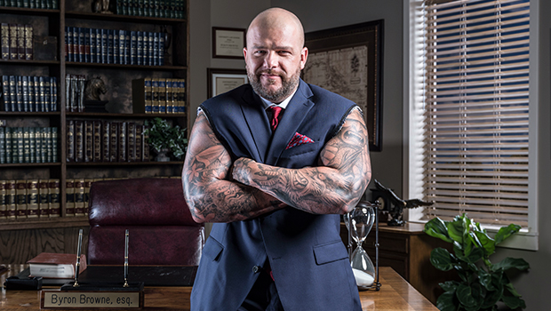

“Dotmount Communications on what they promise. They sought out and obtained great opportunities for me. Professional and very good communication.” **– Trial Attorney Byron Browne**

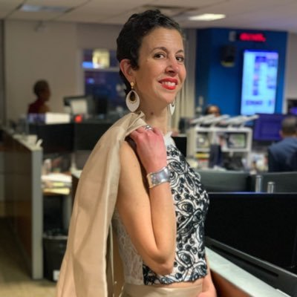

“Dotmount Communications is a reliable and efficient PR firm. They think ahead of the curve, always tries to localize news stories and are creative with topics. They are a good contact or mind…and one I would suggest to others in need of a resource.” **– Enez Paganuzzi Planning Manager at WNBC-TV**

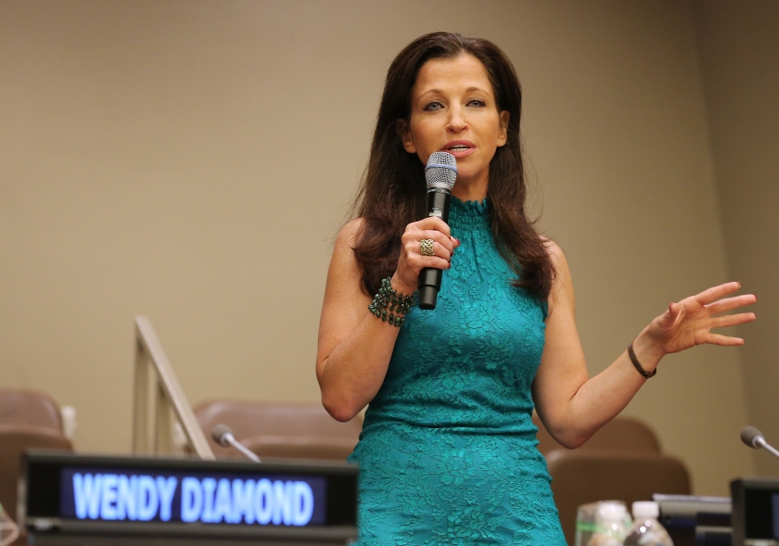

“Adedotun and Dotmount Communications are two angels in the media world! Persistent with always a sense of humor in this dog eat dog world! Grateful for their support in our many efforts over the years in creating a positive impact in the world of animals!” **– Wendy Diamond / Animal Fair Magazine Founder & Founder at Women’s Entrepreneurship Day**



“As a strategic partner I would describe *Dotmount Communications* as having a team of savants.   
Their expertise in executive branding & strategy is superb.  I often marvel at their understanding of brand penetration. And their application is often flawless.   
They are the LeBron James of branding: smart, polished, and thorough. He keeps me on my toes and there is no one I’d rather call when I need a question answered or an expert viewpoint. (Imagine Kobe calling LeBron!)   
Being in the same industry, I often run across competitors who have no idea what they are doing.  *Dotmount Communication* is just the opposite. *Dotmount Communication* is your favorite brand manager’s brand manager.   
If I were a Fortune 100 CEO or a talent with a major brand, they could represent me in a heartbeat. They are that good.”**– ARTHUR SMITH**, AGS Media

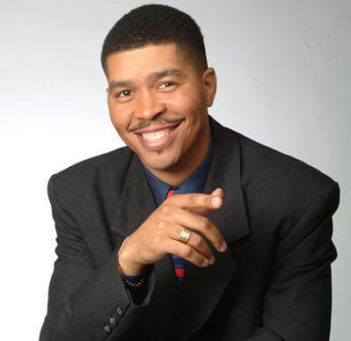

*“There are people who create business, people who secure business, and people who maintain business. In my nine years with Dotmount Communications, I’m happy to say that they have provided all three. It’s been one of the best decisions in my life to join them in their mission to provide the most opportunities and business management for respected clients.  Dotmount Communicationst is well worth the investment.”* **– OMAR TYREE**, New York Times Best-Selling Author